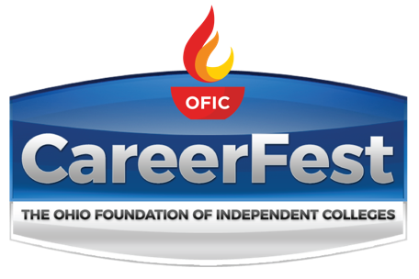

January 31, 2020
Ohio Expo Center
Kasich Hall

Columbus, Ohio
10:00 am – 2:00 pm

STUDENT GUIDEBOOK

Presented by
The Ohio Foundation of Independent Colleges
and its 33 member institutions

FT = Full-time positions available | Paid/Unpaid INT = Paid and Unpaid Internships available

PT = Part-time positions available | COOP = Cooperative positions

OFIC Member Campuses
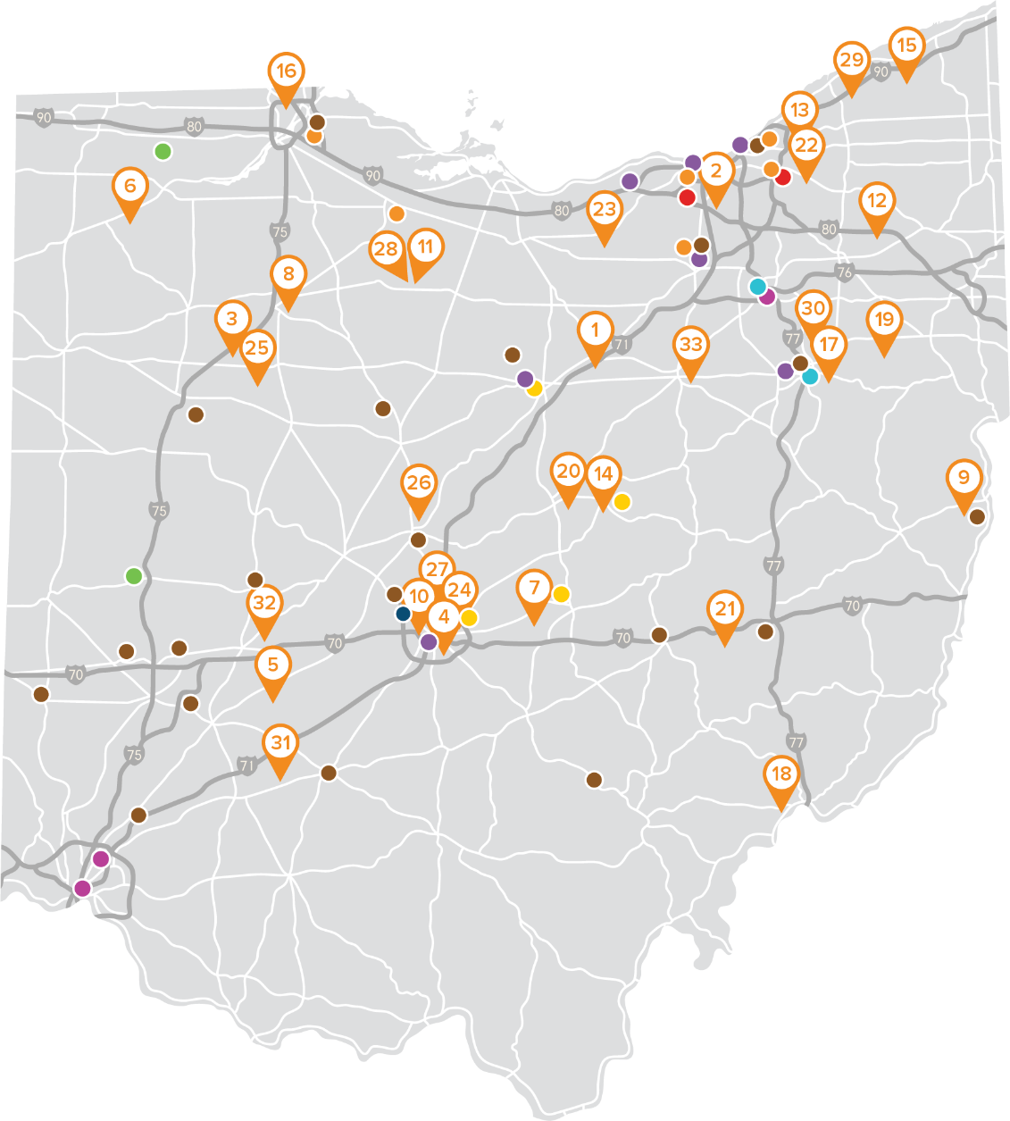
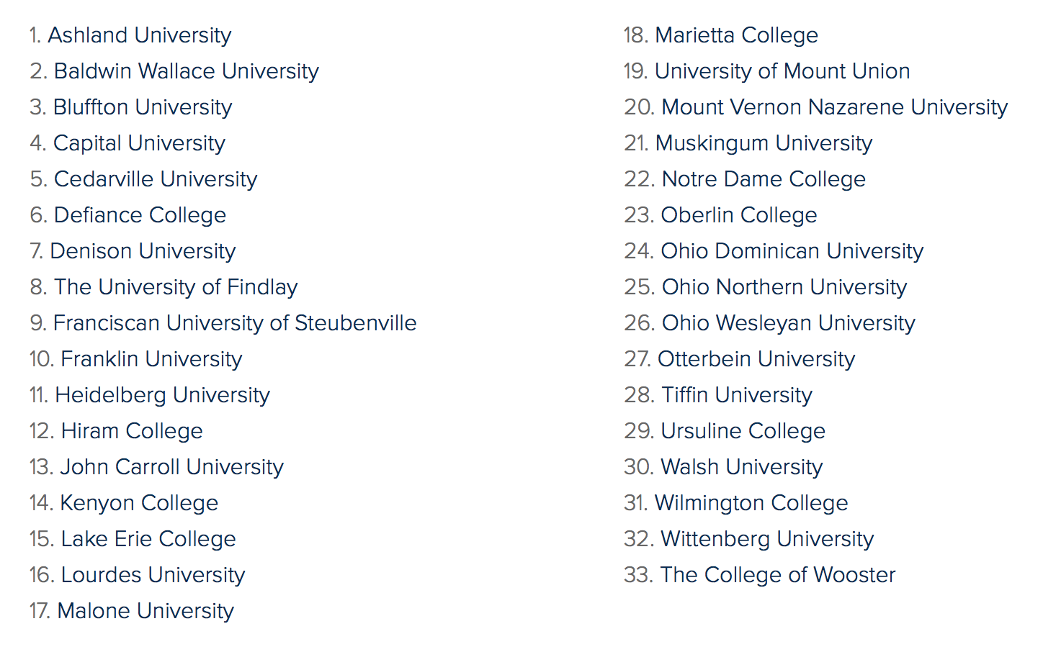

21st Century Financial
Booth
FT/Paid INT
130 Springside Drive, Suite 100
Akron, OH 44319
www.xxiadvisors.com
Academic background required: All
Positions/Qualifications: Financial Adviser. We are dedicated to making an impact in the lives of others—including our Advisors.

21st Century Financial is seeking a talented individual who seeks to make an impact in the lives of others. Our team is comprised of ambitious, visionary, success driven individuals who are in control of their career away from corporate ladders. For a like-minded individual, we offer:
• Base compensation plus commissions (with appropriate licensing)
• Flexible work schedule, high-income potential
• Rewarding work-life balance
• Resources and tools to build a rewarding career as a financial professional.

At 21st Century Financial, we help people unlock life’s possibilities. To do that, we work side by side with a new Advisor to raise the bar—and then leap over it. It is a culture of continuous improvement and learning, of collaboration and creativity.
Responsibilities:
• Prospecting for clients
• Building your practice
• Providing financial education and strategic solutions to clients
• Collaborating with our team to maximize resources
• Maintaining long-term relationships with your clientele
• Learning and improving on a continuous basis

Do you have what it takes to create a business for yourself?
Requirements
• Strong relationship skills and a desire to be in a relationship driven career
• College degree, or military equivalent preferred
• Sales or business development experience is preferred
• Qualified to work in the United States for any employer
• Reside in the area for three or more years
• Ability to pass background check and drug screening
• Community involvement

Compensation and Benefits:
• Base compensation for a new adviser as you grow your commission-based income
• Transition compensation when applicable
• Results driven compensation
• Flexible work schedule
• Ability to work remotely
• Comprehensive rewards, trips, and recognition opportunities
• Full benefits package including insurance and retirement benefits

Training:
• Extensive resources to master financial knowledge, including designation reimbursement
• Weekly coaching to support growth of a practice for new and expert advisors
• Ongoing practice advancement, continuing education, and growth opportunities
• Support in obtaining licenses required for the industry (Series 6 or 7, Life, Health & Disability Insurance License, etc.)
We are an equal opportunity employer. 2443719TM_Mar21

Auto-Owners Insurance Company
Booth
FT/Paid INT
2325 N. Cole St.
Lima, OH 45801
www.auto-owners.com
Academic background required: All majors accepted
Positions/Qualifications: Entry Level Insurance Claim Representative, Entry Level Insurance Underwriter, Intern

Baldwin Wallace University
Booth
Paid INT
275 Eastland Road
Berea, OH 44017
www.bw.edu
Academic background required: The BW Office of Admission works to establish opportunities for students to complete their educational goals. BW offers the following graduate programs: MMS Physician Assistant, MS Speech-Language Pathology, MPH Public Health, MBA, MACC, MA in Management, MAEd Leadership in Higher Education, MAEd for licensed teachers, initial license + MAEd, an Accelerated Bachelor of Science in Nursing (ABSN), and a professional post-baccalaureate program in music therapy.
Positions/Qualifications: Graduate internships available within our Leadership in Higher Education (LHE) MAEd. Program

Battelle Memorial Institute
Booth
COOP
505 King Ave.
Columbus, OH 43201
www.battelle.org/careers
Academic background required: Mechanical Engineering, Computer Science and Engineering, Electrical Engineering
Positions/Qualifications: TBD – Fall 2020 Co-ops

BMW Financial Services
Booth
FT/Paid INT
5550 Britton Parkway
Hilliard, OH 43026
www.bmwgroup.jobs
Academic background required: All majors, hiring primarily for customer service positions or internships.
Positions/Qualifications:

Charles Schwab
Booth
FT/Paid INT
4150 Kinross Lakes Pkwy.
Richfield, OH 44286
www.schwabjobs.com
Academic background required: No specific major or GPA requirement
Positions/Qualifications:

City Year
Booth
FT
350 East 1st Ave., Suite 250
Columbus, OH 43201
www.cityyear.org
Academic background required: All majors
Positions/Qualifications: City Year AmeriCorps Member
Applicants must:
• Be between 18-25 years old
• Be a U.S. citizen or legal permanent resident
• Have a college degree, some college experience, GED or high school diploma

Columbus Young Professionals Club
Booth
Paid INT/Unpaid INT
175 S. Third Street, #200
Columbus, OH 43215
www.cypclub.com
Academic background required: Seeking young professionals looking to connect in Columbus! Columbus Young Professionals is a membership organization that serves as a hub for social & business networking, recreational sports, workforce development, and giving back in Columbus. Founded in 2005, the CYP Club has grown into the largest membership association for young professionals in the nation. Our mission is to offer connections, access, and value for our members through professional and fun events, quality athletics, and community impact.
Positions/Qualifications: Events Intern, CYP Club Cares (service board) intern

Crown Equipment Corporation
Booth
FT/COOP/Paid INT
44 South Washington Street
New Bremen, OH 45869
www.crown.jobs
Academic background required: We are looking to fill internships and fulltime roles in the following areas....
Mechanical Engineering
Electrical Engineering
Computer Science Engineering
Software Development
Business Administration - Marketing, Customer Service, and Sales
Supply Chain/Purchasing
Logistics
Data Analytics
Positions/Qualifications: Co-op Positions, Internships, Fulltime

DeVry University
Booth
FT
1350 Alum Creek Drive
Columbus, OH 43209
www.devry.edu
Academic background required: business, education, information technology
Positions/Qualifications: – Student Support Associate (associate degree required, bachelor preferred), Student workers

Diamond Hill Capital Management
Booth
FT/Paid INT
325 John H. McConnell Blvd.
Columbus, OH 43215
www.diamond-hill.com
Academic background required: We are open to any majors. Most common are: finance, business, accounting, economics, marketing, investments, business analytics
Positions/Qualifications: International Investment Internship, Distribution Internship, Marketing Internship, Business Analyst, Research Associate, Business Development

DLA Land and Maritime
Booth
FT/Paid INT
www.dla.mil
Academic background required: Engineering, Contracting, Supply, Procurement and Customer Account
Positions/Qualifications: Engineers, Contract Specialist, Supply Specialist, Procurement Specialist, Customer Account Specialist

Enterprise Holdings
Booth
FT
3245 Morse Road
Columbus, OH 43230
www.goenterpriseholdings.com
Academic background required: Bachelor’s Degree Required - All Majors
Positions/Qualifications: Sales Management Trainee

Franklin County Sheriff’s Office
Booth
FT
410 South High Street, 2nd Floor
Columbus, OH 43215
www.sheriff.franlincountyohio.gov
Academic background required: Law Enforcement, Criminology, Criminal Justice, Public Safety
Positions/Qualifications: Deputy in Corrections, Facility Security, Patrol Communication Technician (911 Dispatcher), Storekeeper, Identification Technician, Corrections Records Officer, Corrections Service Coordinator, Typist/Secretary

HBK CPAs & Consultants
Booth
FT/Paid INT
6603 Summit Drive
Canfield, OH 44406
www.hbkcpa.com
Academic background required: Accounting, Finance and Business Administration majors will be considered.
Positions/Qualifications:

Intern Qualifications:
-Must be a Junior or Senior Accounting major with a minimum 3.0 GPA.
-Interns should have completed Intermediate accounting and a minimum of one tax class.
-Interns must have excellent computer skills, communication skills and interpersonal skills.
-Interns must be team players.
-Interns must pass an employment background check.

Full-Time Associate Qualifications:
-Bachelor's degree required. Master Degree, CPA or eligibility to sit for CPA preferred.
-1-4 years of accounting experience.
-Strong tax compliance skills.
-Experience with computerized tax software programs.

IES Abroad
Booth
FT/Unpaid INT
33 West Monroe, Suite 2300
Chicago, IL 60603
www.iesabroad.org
Academic background required: All Majors, All Backgrounds, Full-Time Internships Abroad
Positions/Qualifications: Full time 8 week summer internships abroad

JP Morgan Funds
Booth
FT
1111 Polaris Parkway, Suite 2D
Columbus, OH 43240
www.jpmorganfunds.com
Academic background required: Business and Finance
Positions/Qualifications: Shareholder Services is a key entry level role within J.P. Morgan Asset Management. As a Shareholder Services Analyst, one will be responsible for customer service support our financial advisors throughout the country as well as shareholders of J.P. Morgan Funds. We recruit candidates who possess the energy and attitude that is vital to success in this role and the service skills to continue to build our relationships with our existing clients. Training for new analysts includes the SIE certification, Series 6 & 63 securities licenses as we look for candidates to join our organization and become an important part of the future of Funds Management. Analysts will be accountable for trade processing, client services, product knowledge, and education of our processes. Communication, service skills, and a willingness to learn are paramount to success in this role.

Konecranes
Booth
FT
4401 Gateway Blvd.
Springfield, OH 45502
www.konecranes.com
Academic background required: electrical and mechanical engineering, business management, sales
Positions/Qualifications:
Management Development Program
Agreement Sales
Service Technicians

Lakeside Chautauqua
Booth
Paid INT
236 Walnut Ave.
Lakeside, OH 43440-1400
www.lakesideohio.com
Academic background required: Business administration, finance, advancement, fundraising, accounting, information technology, management, social media, public relations, marketing, communications, design/technology, digital communications, graphic design, visual communications technology, print communications, photography, media, broadcasting, education, youth education, history, group sales, event planning, database management, journalism, English, Adobe InDesign, newspaper, operations, leadership, media communications, political science, library science, hospitality, tourism, arts, entertainment, music, landscape management, horticulture, recreation, wellness, exercise, nutrition
Positions/Qualifications:
• Accounting/IT Support
• Advancement Events
• App & Digital Communications
• Art Center
• Arts/Entertainment Management
• Conference & Event Planning
• Educational Event Planning/Promotions
• Environmental
• Horticulture
• Hospitality Management
• IT Support
• Newspaper Publication Design
• Photography
• Programming/Religious Life
• Recreation
• Video

Lima Memorial Health System
Booth
FT/PT
1001 Bellefontaine Ave.
Lima, OH 45804
www.limamemorial.org
Academic background required: This info will be listed on our 'registered companies' page to help provide students with the opportunity to research organizations that fit their interests prior to the event.

Lima Memorial Health System is dedicated to providing quality healthcare in a family atmosphere, serving the community where we live and work. At Lima Memorial, you aren't just a number, a medical condition, or a diagnosis. You are a patient, and we consider our patients to be a member of the Lima Memorial family. Our commitment to great care is evident throughout our health system from our soothing, private patient suites and extra time our caregivers spend with patients, to the helpfulness of our dedicated volunteers. We offer the high level of quality care and specialty services that can be found at larger hospitals outside of our region, but in a compassionate, family atmosphere that is close to home.

We are looking for employees who share our values, are committed to providing great care, and have a passion for improving the quality of life in the communities we serve. Specific areas of study for which we are most highly interested are: Medical Providers (Physicians, Certified Registered Nurse Anesthetists), Nursing (RN and LPN), Certified Medical Assistant, Surgical Technician, Polysomnographic Technician, and Phlebotomist.
Positions/Qualifications: Certified Registered Nurse Anesthetists - The Lima Memorial team is composed of anesthesiologists and certified registered nurse anesthetists (CRNA). Designated as a Level II Trauma Center, the health system treats complex cases, including neurosurgery, open-heart and complex fractures. In addition, Lima Memorial has a robust obstetrics department with a Level II Nursery.

Registered Nurse - assumes responsibility and accountability for the care of assigned patients on his/her shift. RN responsibilities include assessing, planning, implementing and evaluating patient care using age specific criteria. Judgments are made based upon scientific knowledge and clinical skills. The RN also assists in planning, directing and teaching non-RN staff such as LPN and Patient Care Technicians.

Polysomnographic Technologist - provides comprehensive evaluation and treatment of sleep disorders including sleep apnea testing, diagnostic and therapeutic interventions, comprehensive patient care and direct patient education. Responsibilities include collecting, analyzing and integrating patient information in order to meet the patient-specific needs; determining final testing parameters in conjunction with the physician and established protocols; reviewing the patient’s history and verifying the medical order(s); selecting appropriate equipment and calibrating for testing, applying electrodes and sensors according to accepted published standards, and performing routine positive airway pressure (PAP) interface fitting and desensitization.

Surgical Technician - assists in the delivery of care for the surgical patient. Case preparation responsibilities include schedule and booking sheet review to verify necessary equipment to be available and complete; assists in moving and positioning patient per Surgeon’s guidelines; participates in time out to confirm procedure and surgeon; and drapes patient within surgeon’s guidelines. Functions as both the primary and the secondary technician in all areas of Surgical Services including, but not limited to, General, Ortho, OB/GYN, Podiatry, Robotics, Urology, Neuro, Vascular, ENT, Plastics, Hybrid, Robotic and Laser cases.

Certified Medical Assistant - assists in the delivery of basic direct patient care under the supervision of a licensed nurse or provider. Clinical duties include preparing patients for exams, obtaining vital signs, performing venipunctures, performing drug screen collections and administering various tests. Performs general office functions including obtaining patient information, establishing patient charts and completing various forms.

Lower.com
Booth
FT
7775 Walton Pkwy, Floor 4
New Albany, OH 43054
www.lower.com
Academic background required: All majors accepted- more that are leaning towards business, sales, finance, etc.
Positions/Qualifications: Here at Lower.com, we offer a guided career path with the appropriate tools and training to become a successful licensed Loan Advisor. Our objective is to elevate your sales skill set and provide effective training on all aspects of a mortgage loan from origination to closing. This career path offers the opportunity for fast-track career advancement. At Lower.com, we take pride in our core values, high-energy culture, and opportunity to share ideas. As an employee, you will have the ability to present innovative ideas for the company and collaborate with other team members by joining one of our five improvement committees.

The Account Manager position is the first fundamental role within our structured sales path, where our employees start to mold the foundation for their career. The Account Manager is responsible for making outbound calls to potential clients and transferring new business leads to Loan Advisors. This position is vital to Lower to ensure a constant flow of new business. The Account Manager will work within the Direct to Consumer sales department to help generate new business with our innovative use of technology. Account Managers will also receive onsite training throughout the entire sales path, therefore experience in the mortgage industry is not required.

We offer:

Competitive Base Salary
Extended Benefit Offerings Including:
Medical/Dental/Vision
Maternity Leave
Life Insurance
LTD/STD
Corporate Wellness Program
Paid Holidays and Paid Time Off

Duties and Responsibilities:
Establish initial communication with potential clients from new business leads.
Develop rapport and maintain strong working relationships with internal and external clients.
Collaborate with Loan Advisors and all management teams to deliver a financial product that best suits the clients’ financial profile.
Acquire and maintain mortgage industry knowledge with support from our in-house training team.
Other duties or special projects as assigned.

Requirements:
Superior customer service.
Ability to effectively communicate over the phone or in an email.
Negotiation skills.
Energetic and forward thinker.
Strong work ethic with attention to detail.

Mueller Industries
Booth
FT
150 Schilling Blvd., Suite 200
Collierville, TN 38017
Academic background required: Areas of Study: Business Management, Supply Chain, and Sales
Positions/Qualifications: Job Summary:
The Sales/Marketing Associate position is part of the company’s Career Development Program (CDP). This entry-level, rotational training and development program is designed to prepare recent college graduates for full time roles within Mueller Industries companies. Associates experience a twelve-month curriculum including classroom programs, on-the-job training, self-development courses, field travel, mentoring, and more. The first six months focuses primarily on company, industry, product, and operations education while the second six months focuses on specialized training and experiences that prepare associates for role readiness. Regardless of career path, these months provide associates with confidence, credibility, and an immeasurable hands-on foundation for future success.

Duties & Responsibilities:
• Successful completion of training coursework, tests, assignments, and projects.
• Productive, safe, efficient, and accurate on-the-job work assignments/rotations.
• Maintain a receptive mindset to development tasks, mentoring, and evaluations.
• Work collaboratively with a flexible, willing attitude and professional image/behavior.
• Once in a Sales/Marketing role, individuals will conduct business and relationship development activities with customers within specific business segments. This entails selling, marketing, problem resolution, consulting, and other functions that promote ongoing business growth.

Requirements:
• Bachelor of Science Degree in Marketing from a regionally accredited institution
• Minimum 2.75 cumulative GPA
• Possess and maintain a valid and unrestrictive driver’s license
• Must be geographically flexible to relocate within assigned region upon placement
• Must be authorized to work in the U.S. without company sponsorship
• Relocation and/or temporary living reassignment
• Cohabitation with other Career Development Program Trainees
• Excellent communication and interpersonal skills (verbal and written)
• Energetic, competitive, self-motivated, and mature professional character
• Ability to take initiative, meet deadlines, and perform under minimal supervision
• Proficient in the use of Microsoft Office (Outlook, Excel, Word, PowerPoint, etc.)

Job Summary:
The Supply Chain Management Associate position is part of the company’s Career Development Program (CDP). This entry-level, rotational training and development program is designed to prepare recent college graduates for full time roles within Mueller Industries companies. Associates experience a twelve-month curriculum including classroom programs, on-the-job training, self-development courses, field travel, mentoring, and more. The first six months focuses primarily on company, industry, product, and operations education while the second six months focuses on specialized training and experiences that prepare associates for role readiness. Regardless of career path, these months provide associates with confidence, credibility, and an immeasurable hands-on foundation for future success.

Duties & Responsibilities:
• Successful completion of training coursework, tests, assignments, and projects.
• Productive, safe, efficient, and accurate on-the-job work assignments/rotations.
• Maintain a receptive mindset to development tasks, mentoring, and evaluations.
• Work collaboratively with a flexible, willing attitude and professional image/behavior.
• Once in a supply chain management role, individuals will conduct business and relationship development activities with customers within specific business segments. This entails selling, marketing, problem resolution, consulting, and other functions that promote ongoing business growth.

Requirements:
• Bachelor of Science Degree in Supply Chain Management or other business related degree from a regionally accredited institution
• Minimum 2.75 cumulative GPA
• Possess and maintain a valid and unrestrictive driver’s license
• Must be geographically flexible to relocate within assigned region upon placement
• Must be authorized to work in the U.S. without company sponsorship
• Relocation and/or temporary living reassignment
• Cohabitation with other Career Development Program Trainees
• Excellent communication and interpersonal skills (verbal and written)
• Energetic, competitive, self-motivated, and mature professional character
• Ability to take initiative, meet deadlines, and perform under minimal supervision
• Proficient in the use of Microsoft Office (Outlook, Excel, Word, PowerPoint, etc.)

National Interstate Insurance
Booth
FT/Paid INT
3250 Interstate Drive
Richfield, OH 44286
www.careers.natl.com
Academic background required:
Positions/Qualifications:

Northstar Café
Booth
FT
1442 West Lane Ave
Columbus, OH 43221
www.thenorthstarcafe.com
Academic background required: Business, Hospitality, Culinary Arts, Communications, Psychology
Positions/Qualifications: Restaurant Management Team

OCLC
Booth
FT/Paid INT
6565 Kilgour Place
Dublin, OH 43017
www.oclc.org
Academic background required: Various internships / Computer Science / Engineering
Positions/Qualifications: Various Internships - requirements are to be full time student

Ohio Auditor of State
Booth
FT/PT/COOP/Paid INT
88 East Broad Street, 3rd Floor
Columbus, OH 43215
www.ohioauditor.gov
Academic background required: Accounting majors
Positions/Qualifications:

1) Internship - Interns must be enrolled in a baccalaureate or masters accounting program from accredited college or
University

2) Full-time auditor- Bachelor’s degree from accredited college or university (Accountancy degree preferred)
- OR successful completion of at least 16 semester hours or equivalent in accounting or related field from an accredited college, university, trade, technical or vocational school beyond high school level
- OR possess at least three years’ experience in accounting or related field per Section 117.09 of the Ohio Revised Code

Ohio Department of Medicaid
Booth
FT/PT/Paid INT
50 West Town Street, Suite 400
Columbus, OH 43215
www.careers.ohio.gov
Academic background required: Health Care Administration, Business, Statistics, Mathematics, Statistics, Public Administration, Public Affairs, Economics, Political Science, Data Analytics
Positions/Qualifications: College Internship (Undergraduate & Graduate) - Must be enrolled in accredited college or university

Ohio Legislative Service Commission
Booth
FT
77 South High Street, 9th Floor
Columbus, OH 43215
www.lsc.ohio.gov/fellowship
Academic background required: Political Science, History, Journalism, English, Psychology, Education, Public Relations, Government, Public Administration, Classics, Business Administration, Education Policy, Policy, Politics, Communication, Mass Media, Public Broadcasting, Public Affairs, and Humanities.
Positions/Qualifications: Twenty fellows are assigned to work with the majority or minority party caucus in either the House or the Senate. Two are assigned to LSC's Office of Research and Drafting and Legislative Budget Office. Two are assigned to Ohio Government Telecommunications (OGT)/The Ohio Channel. All applicants are required to hold a bachelor's degree by the start of the program in December.

OhioGuidestone
Booth
FT/PT/Unpaid INT
303 East Bagley Road
Berea, OH 44017
www.ohioguidestone.org
Academic background required: OhioGuidestone offers a blend of behavioral health treatment services, skill building programs and prevention opportunities for children and families. We not only help resolve problems that already exist, but teach skills to help individuals become self-sufficient, and prevent future obstacles to success.
At OhioGuidestone, you’ll get the experience you need to be the best in your field. We offer great supervisors, a strong support network, premium benefits, free onsite CEU training, and much more! We need people who believe in our mission, support our vision, and live out our values to make a difference in the lives of individuals in need.
Positions/Qualifications:

PACCAR
Booth
FT/Paid INT
65 Kenworth Drive
Chillicothe, OH 45601
www.paccar.com
Academic background required: Engineering, Operations Management, Accounting, IT, Human Resources, Logistics, Industrial Maintenance, Robotics
Positions/Qualifications: Engineering - Electrical, Mechanical, Industrial, Welding, Robotic, Operations Management, Accounting, IT, Human Resources, Logistics, Industrial Maintenance, Robotics

Peoples Bank
Booth
FT
138 Putnam Street
Marietta, OH 45750
www.peoplesbancorp.com
Academic background required: Hiring all majors. Relevant experience in banking, retail, sales, finance, arts, marketing, accounting and a variety of other fields will be considered.
Positions/Qualifications:
Professional Development Associate

Job Description:
The Professional Development Associate will experience a series of rotations throughout the organization. These rotations are design to teach as well as build the skills and competencies necessary to deliver ethical solutions for our clients. There will be deep learning around the financial issues that face consumers and business. Customer focused skills will be interwoven with a series of Leadership experiences. When complete, the Professional Development Associate will be prepared for a customer facing career with Peoples Bancorp. Professional Development Associate’s primary responsibility will be to learn our overall operating procedures, our sales processes and our service processes. This will include on the job training, with actual responsibility for certain tasks as assigned by Manager, in the following disciplines: sales, customer service, problem solving and back-shop support. Additional education will be conducted on effective selling skills of financial products, sales leadership, prospecting, pre-call planning and closing the deal.
Minimum Qualifications:
Four-year degree
US work authorization

Progressive Insurance
Booth
FT/Paid INT
6300 Wilson Mills Road
Mayfield Village, OH 44143
www.progressive.com/careers
Academic background required: Bachelor’s degree in quantitative area of study (e.g.; Business Analytics, Economics, Mathematics, Statistics, Finance, or Computer Science with a focus on data analysis)
Positions/Qualifications:

Analyst (Full Time)
Must-have qualifications: Bachelor’s degree in quantitative area of study (e.g.; Business Analytics, Economics, Mathematics, Statistics, Finance, or Computer Science with a focus on data analysis)

Preferred skills:
•Cumulative GPA of 3.2 or higher
•Prior internship experience
•Proven leadership experience
•Solid organizational, written and verbal communication and problem-solving skills
•Demonstrated analytical abilities and practical knowledge of SAS, Tableau or other analytical tools, such as Python, R, Google Analytics and SQL

Data Analyst Intern
Knowledge, skills, and experience:
•Pursuing a Bachelor’s degree in a quantitative area of study (e.g.; Economics, Mathematics, Statistics, Actuarial Science
or other Quantitative discipline)
•Planned graduation within one year of completing internship

Preferred skills:
•Cumulative GPA of 3.2 or higher
•Intermediate communication skills, verbal and written, as well as listening and interviewing
•Intermediate organizational (planning, time management, priority management) and problem-solving skills
•Proficient knowledge of Microsoft Office tools (Word, Excel, PowerPoint, Access, etc.
•Demonstrated analytical abilities and practical knowledge of SAS, Tableau or other analytical tools, such as Python, R,
Google Analytics and SQL

Quantum Health
Booth
FT/Paid INT
7450 Huntington Park Drive
Columbus, OH 43235
www.quantum-health.com
Academic background required: Quantum Health considers people from all areas of study for employment. Internships are available in the following areas: Accounting, Business Intelligence, Business Operations, Client Engagement, Clinical Operations, ePMO, Human Resources, Instructional Design, IT (Infrastructure, Quality Assurance, and App Dev), Legal, Population Health, and Technical Operations.
Positions/Qualifications:
Patient Service Representative
Spanish Speaking Patient Representative - must be fluent in both English and Spanish

The Ronald Reagan Institute
Booth
Paid INT/Unpaid INT
1455 Pennsylvania Ave., NW, Suite 850
Washington, DC 20004
www.reaganfoundation.org
Academic background required: All majors, all political orientations considered
Positions/Qualifications:

Reynolds and Reynolds
Booth
FT/PT/COOP/Paid INT
1 Reynolds Way
Kettering, OH 45430
www.reyrey.com/careers
Academic background required: Open to all majors. Great fit for any business, communications, and information technology majors.
Positions/Qualifications: Full-time and internship opportunities available in customer support, consulting, sales, project management, marketing, information technology, and software development. The majority of our opportunities are located at our headquarters in Dayton, Ohio, but we also have sales and consulting roles available nationwide.

SafeAuto
Booth
FT/Paid INT
4 Easton Oval
Columbus, OH 43219
www.safeauto.com
Academic background required: for Analysts - Data Analytics, Computer Science, Actuarial Science; experience required: Predictive data modeling/statistical data modeling in R/Python, SQL, SAS All Bachelors degrees considered for Claims Adjusters Computer Science or other IT related field for IT Developers
Positions/Qualifications: Java Developer - experience/coursework related to back-end/core Java development Front-End Developer - experience/coursework in front-end development (JavaScript, HTML, CSS, Angular/React, etc) Product Analyst - experience/coursework in R or Python, SQL and SAS

Sherman College of Chiropractic
Booth
FT
2020 Springfield Road
Admissions Department
Spartanburg, SC 29304
www.sherman.edu
Academic background required: Students with an undergraduate degree and a strong Science background.
Positions/Qualifications: Adjusting the World for a Better Future
Sherman College of Chiropractic offers a professional degree program leading to the doctor of chiropractic degree; it is one of just 18 chiropractic colleges in the United States and the only one in the Carolinas. On its 80-acre campus in South Carolina, Sherman College provides students with a comprehensive chiropractic education, preparing them to enter the field as highly skilled, compassionate, ethical and successful doctors of chiropractic.
The degree program is unique in its approach to health care and known globally for the skill and art of chiropractic delivered by graduates. For more information, visit www.sherman.edu or call 800-849-8771.

The Sherwin-Williams Co.
Booth
FT/PT/Paid INT
11410 Alameda Drive
Strongsville, OH 44149
www.careers.sherwin-williams.com
Academic background required:
Positions/Qualifications:
Sales/Management Training Program (Full-Time)
Sales/Management 2020 Summer Internship (Part-Time)
Store Sales Associate (Part-Time)

Speedway LLC
Booth
FT/Paid INT
500 Speedway Drive
Enon, OH 45323
www.speedway.com/careers
Academic background required: Marketing, Finance, Accounting, IT/MIS/CS, Criminal Justice/Security, HR/OD, General Business, Economics, Purchasing/Supply Chain/Operations, Management, Engineering - Civil, Electrical, Mechanical, Environmental, Construction Management, Architecture
Positions/Qualifications: Full Time and Internship Positions

State Auto Insurance Companies
Booth
FT/PT/COOP/Paid INT
518 East Broad Street
Columbus, OH 43215
www.stateauto.com
Academic background required: At State Auto, our associates are compassionate, knowledgeable and enthusiastic about doing the right thing for their career, the company and our customers. With benefits like flexible time away, no dress code, and a focus on coaching you to become an elite associate, we have an innovative culture that values competitiveness, courage and community. Come be part of the State Auto team.
ENSURE YOUR CAREER: Accounting/Finance, Actuarial, Claims, Customer Service, Human Resources, Information Technology, Legal, Marketing, Product & Sales, Risk Engineering, Underwriting
Positions/Qualifications: Accounting/Finance, Actuarial, Claims, Customer Service, Human Resources, Information Technology, Legal, Marketing, Product & Sales, Risk Engineering, Underwriting

Total Quality Logistics
Booth
FT
P.O. Box 799
Milford, OH 45150
www.tqljobs.com
Academic background required: All majors
Positions/Qualifications: Sales, Account Management, IT, Finance, Accounting, Marketing

Ursuline College
Booth
FT/PT
2550 Lander Road
Pepper Pike, OH 44124
www.ursuline.edu
Academic background required: Ursuline College is private, co-ed college located approximately 30 minutes from downtown Cleveland, Ohio. We offer graduate degrees in: Counseling and Art Therapy, Historic Preservation, Educational Administration, Initial Teacher Licensure, Theological and Pastoral Studies, and Nursing (MSN, DNP).

USCIS
Booth
FT
1240 East 9th Street, Suite 581
Cleveland, OH 44199
www.dhs.gov
Academic background required:
Positions/Qualifications: OSS, Analyst, ISO officers

Wake Forest University
Booth
FT
1834 Wake Forst Road, Farrell Hall, Suite 115
Winston-Salem, NC 27109
www.business.wfu.edu
Academic background required: The Wake Forest University Accelerated Masters programs are open to candidates from a wide range of majors and experiences.
Master of Science in Management: Open to all non-business majors, business minors are welcome
Master of Science in Business Analytics: Open to all majors
Master of Science in Accounting: Open to all majors

Xavier University
Booth
FT
8425 Pulsar Place
Columbus, OH 43240
www.xavier.edu/nursenow
Academic background required: Xavier is a Jesuit Catholic university rooted in the liberal arts tradition. Our mission is to educate each student intellectually, morally, and spiritually. Want to be a part of your healthcare community? Consider Xavier’s accelerated nursing program fast-tracks you into the profession by leveraging your existing bachelor's degree in a non-nursing discipline. With three start dates in January, April, and August and only 4 pre-reqs, our ABSN program has a spot waiting for you when you're ready to become the nurse you were meant to be. Program locations in Columbus and Cincinnati.

